# Advanced Graphics

# Coursework 2

## Part 1 – Fresnel Reflectance

### Air To Material

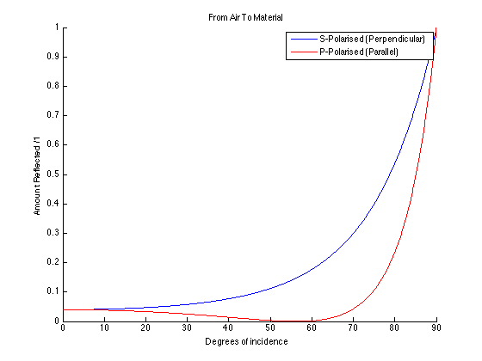

η1 = 1, η2= 1.5

From the graph we can obtain the reflectance of both components at normal incidence (when θ = 0).

|  |  |
| --- | --- |
| S-Polarised: | 0.04 |
| P-Polarised: | 0.04 |

The critical angle of total internal reflection is at 90 degrees.

The Brewster’s angle is the angle of incidence whereby light with a certain polarization is perfectly transmitted with no transmission.

In the diagram above, the Brewster’s angle is 56.3 degrees.

### Material To Air

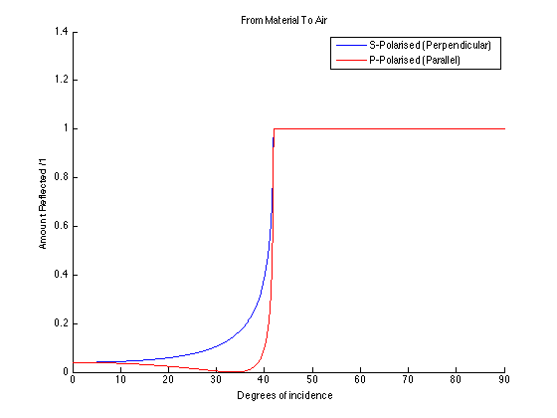

η1 = 1.5, η2= 1

From the graph we can obtain the reflectance of both components at normal incidence (when θ = 0).

|  |  |
| --- | --- |
| S-Polarised: | 0.04 |
| P-Polarised: | 0.04 |

The critical angle of total internal reflection is at 41.9 degrees.

The Brewster’s angle is the angle of incidence whereby light with a certain polarization is perfectly transmitted with no transmission.

In the diagram above, the Brewster’s angle is 33.7 degrees.

## Part 2

64 samples

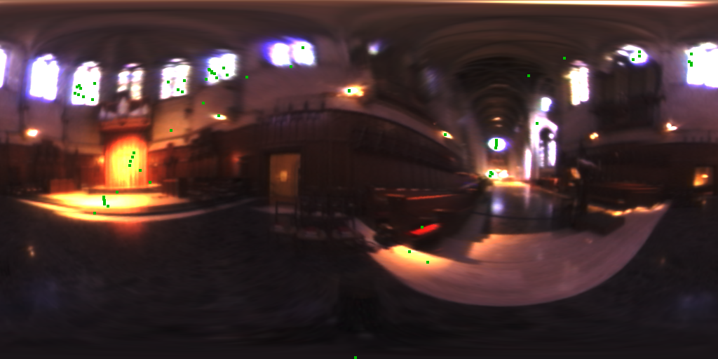

256 samples

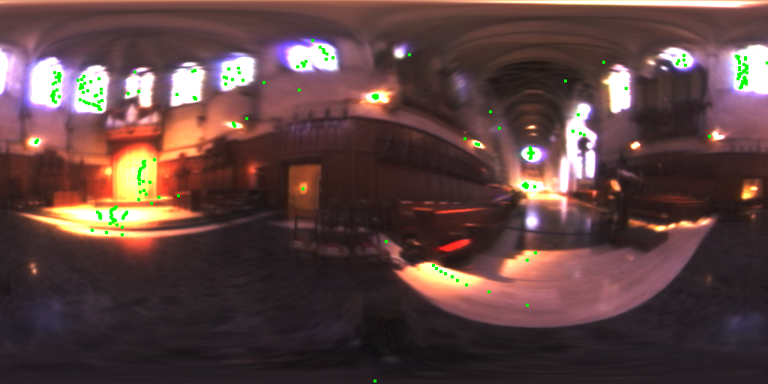

1024 samples



## Part 3

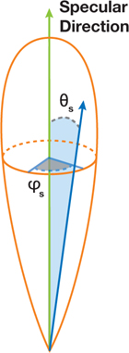

The objective is to perform importance sampling on the Specular component of the Phong Model. We assume that the local surface normal is aligned with the north pole (Y axis) of the EM. Furthermore, We align the specular reflection direction with the North Pole of the EM. We use the equation from the notes to generate values for θs and φs. The φs value does not determine specular reflectivity therefore it is completely random. The θs value does however determine how much specular reflectivity is observed.

As we increase the Phong component **n**, the required angle between the observer and the outgoing specular light (necessary so that the observer witnesses the specular reflection) becomes smaller and smaller. From our results, we see that increasing **n** causes our sampler to sample from a closer range of light sources.

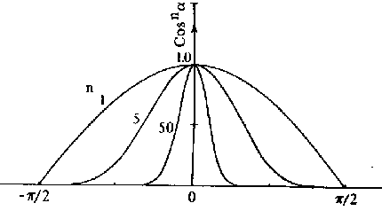

Sample Size: 1024

N = 1

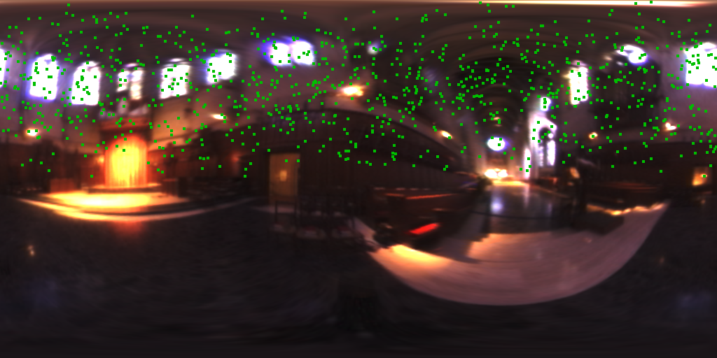

N = 10

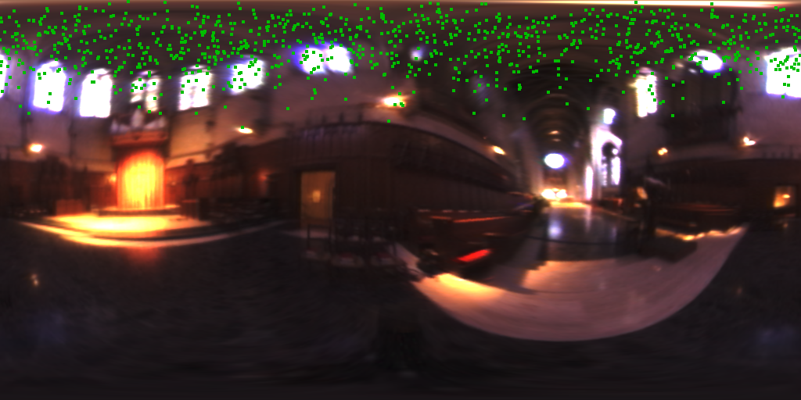

N = 50

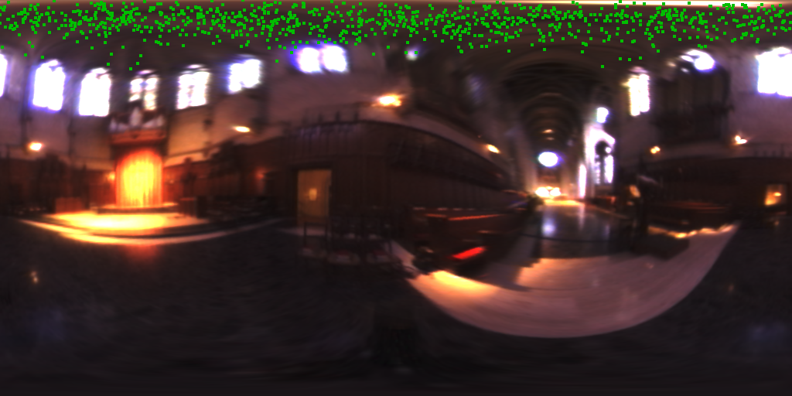

N = 200

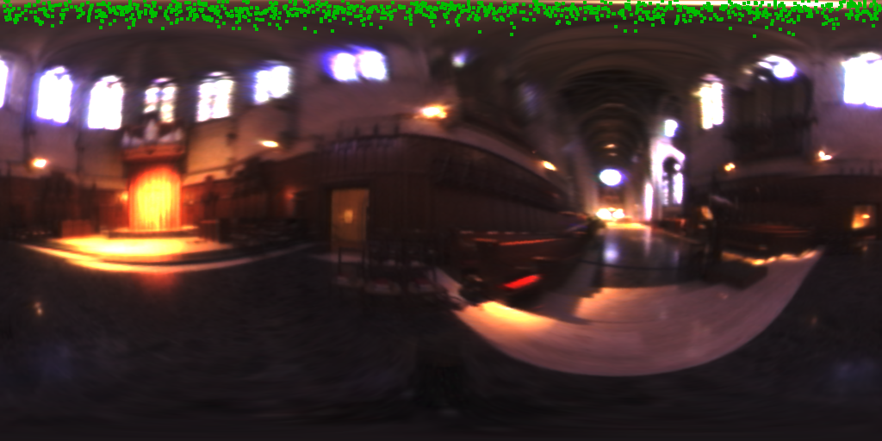

## Part 4

We ignored samples where the angle between the normal and incident light is more than 90 degrees because these light sources would not be visible from that point on the sphere.

64 samples



256 samples

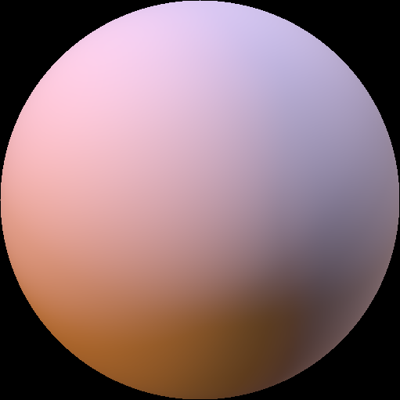

1024 samples

